- Create a new worksapce in eclipse.
- Configure the JDK(Must be JDK folder)
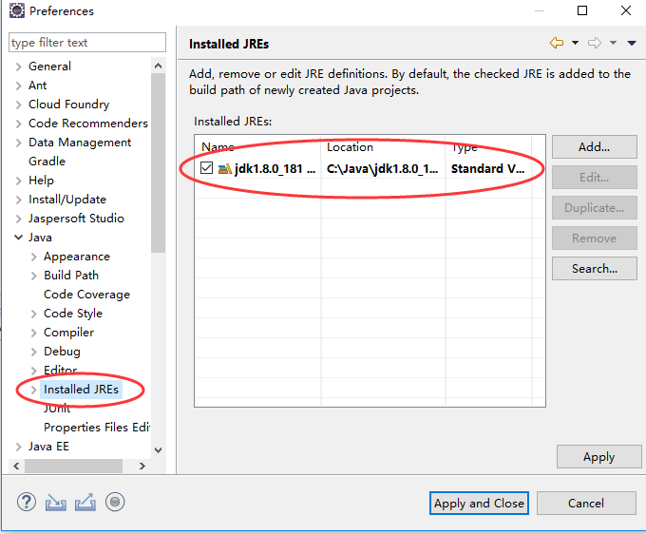

- Configure the Maven
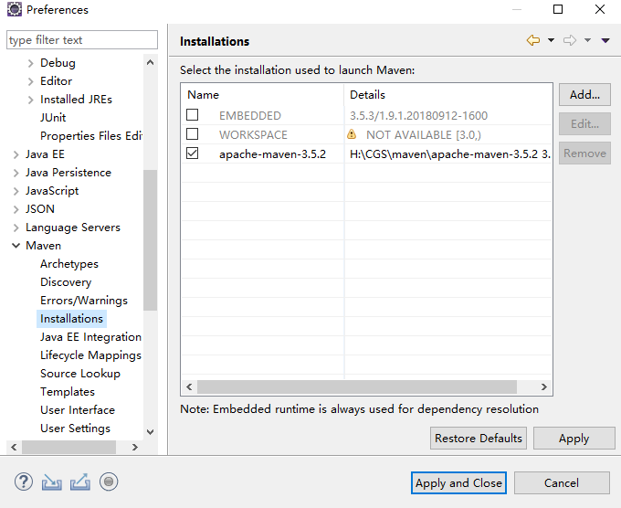

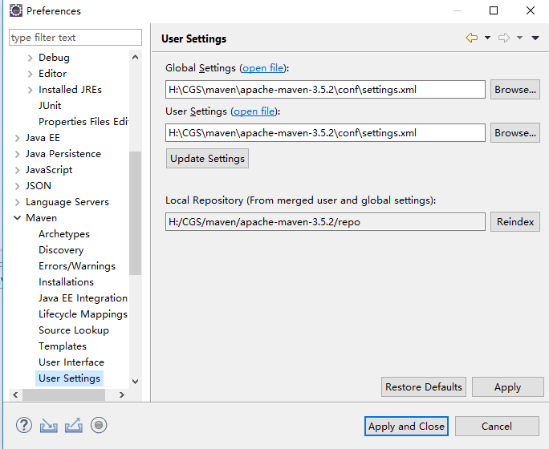

- Import the cgs-schedule-pom project.
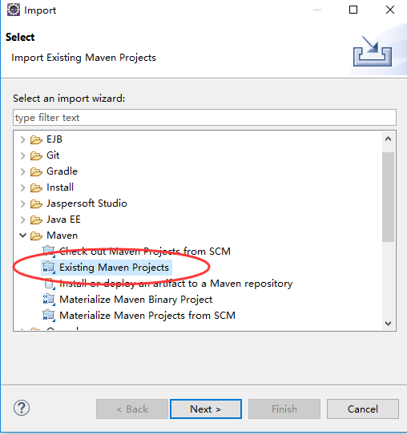

- Build the cgs-schedule-pom project.
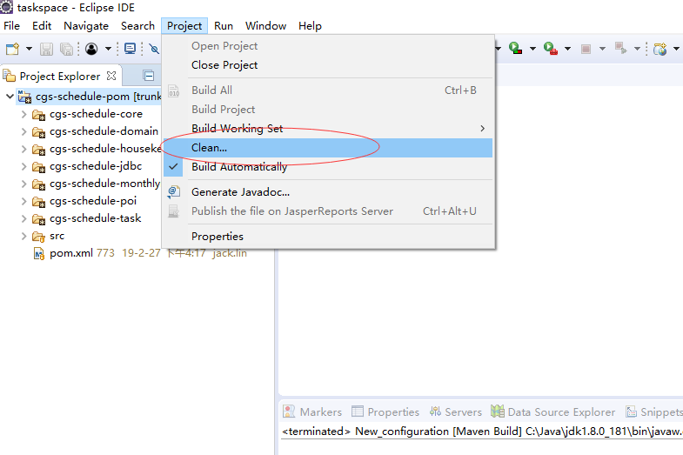
- Click the “Run -> Run Configurations...” menu.
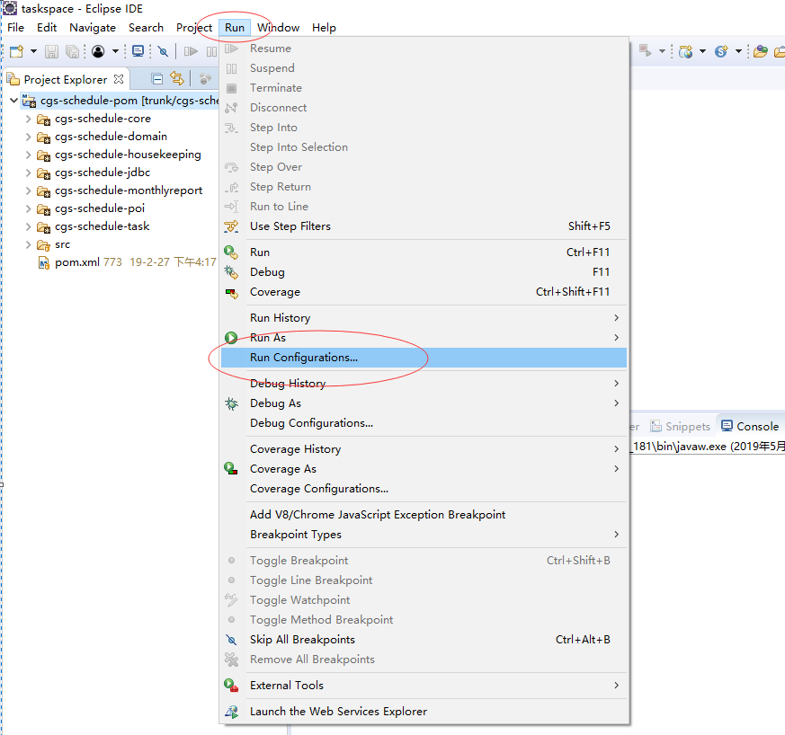

- Double click the ”Maven Build”
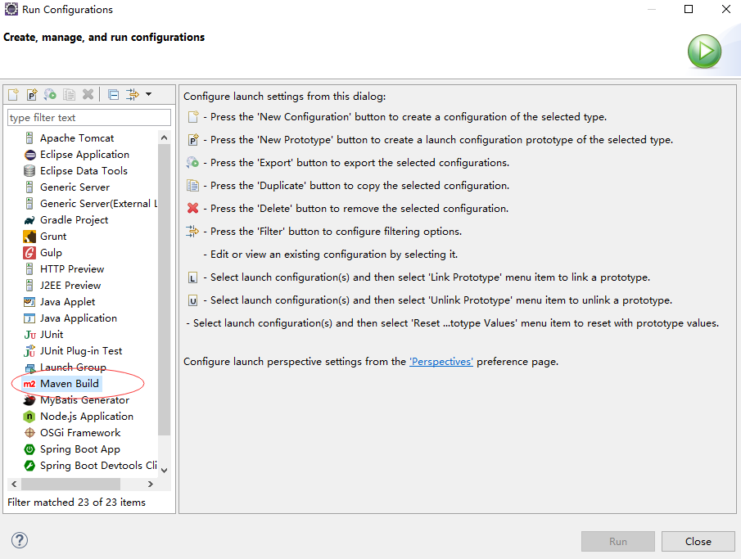

- Click the “New_configuration”
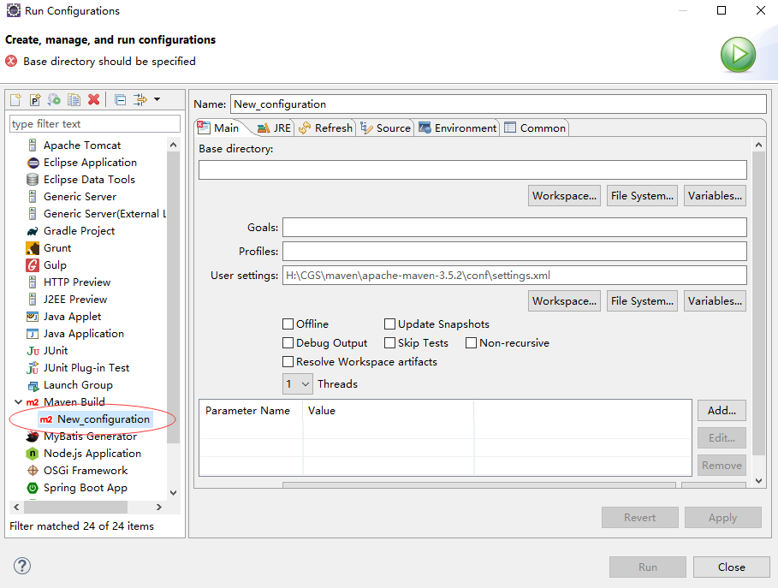

- Click the “Workspace...” button and select the “cgs-schedule-pom”
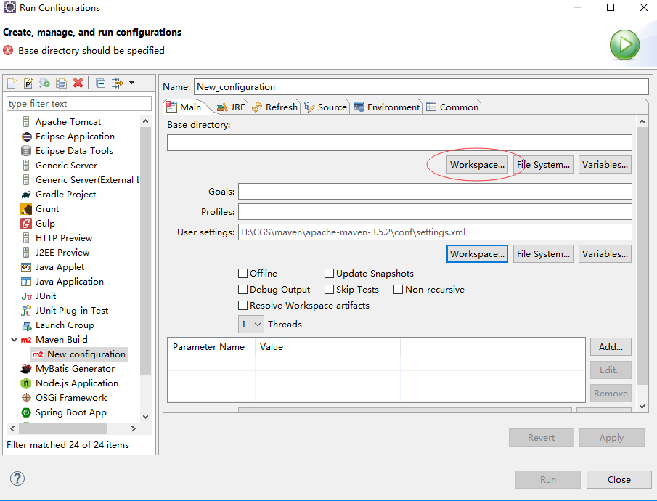
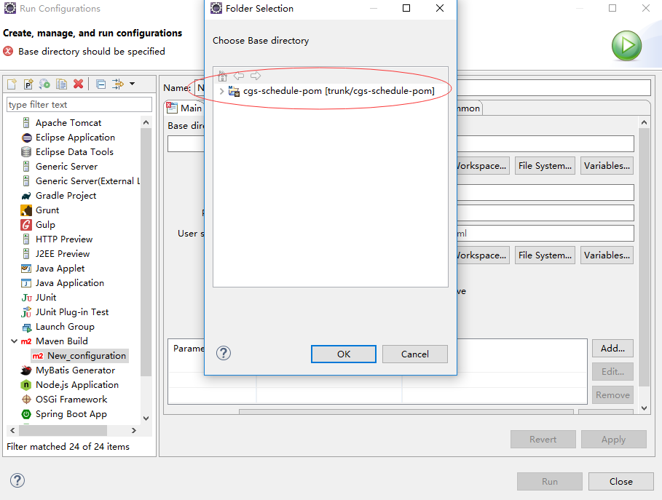
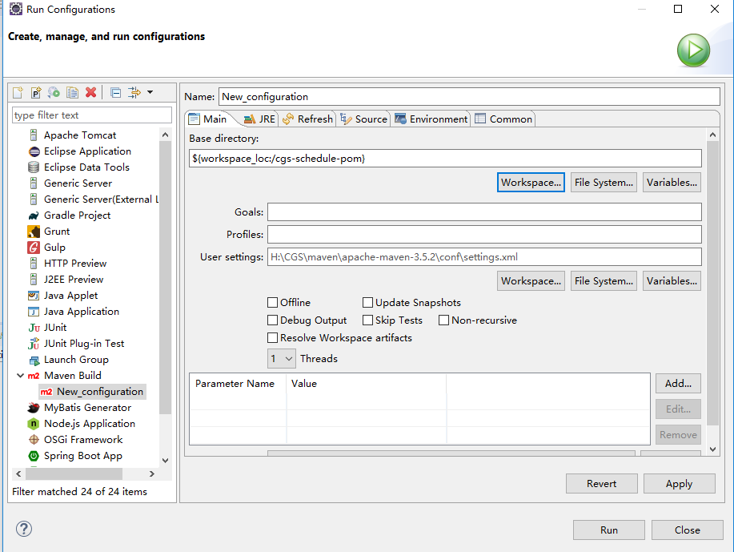

- Input the “clean package” command in the Goals item and check the Skip Tests item.
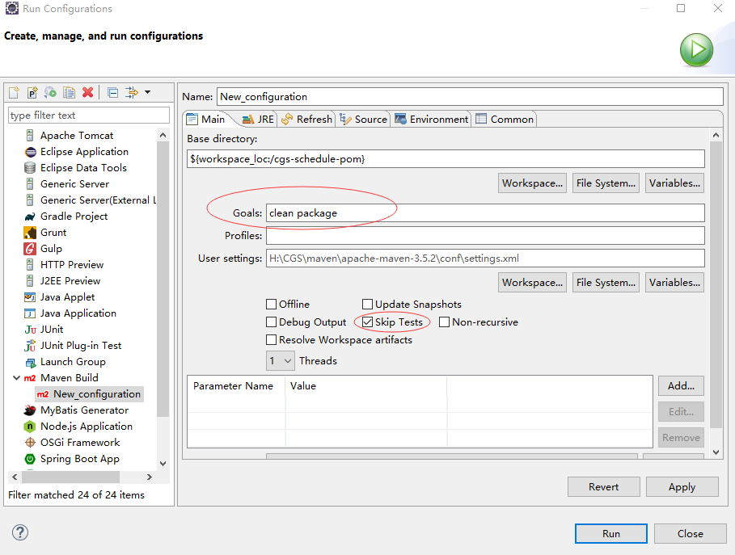

- Click the “Run” button
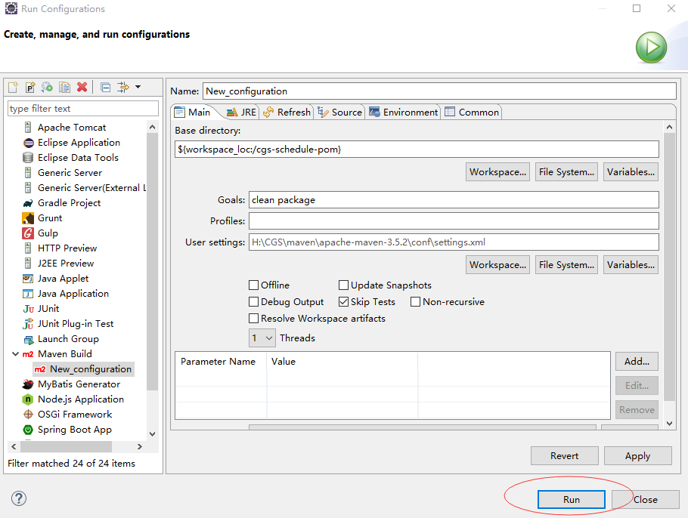
- Right the cgs-schedule-pom project and click the “Refresh” menu.
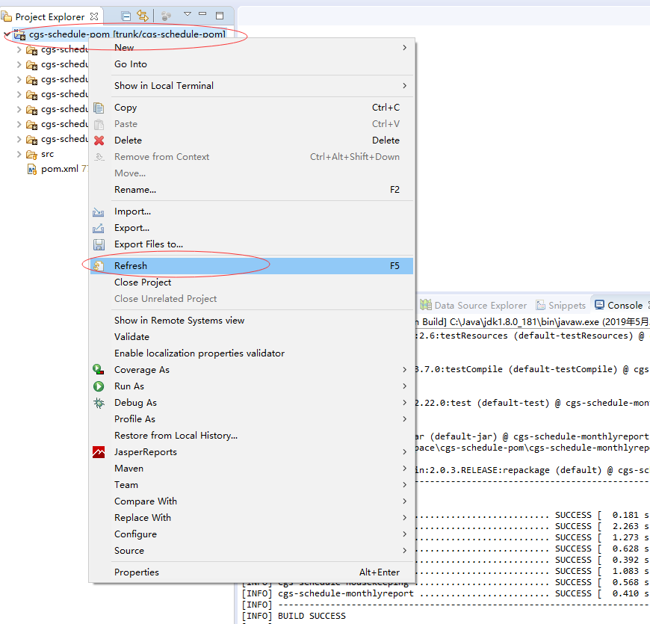

- Find the “cgs-schedule-housekeeping-0.0.1.jar” and the “cgs-schedule-monthlyreport-0.0.1.jar” files.
